**Name: Adithya M SRN: PES1UG20CS621 SEC: K**

**Language: a*(a+b)ab**

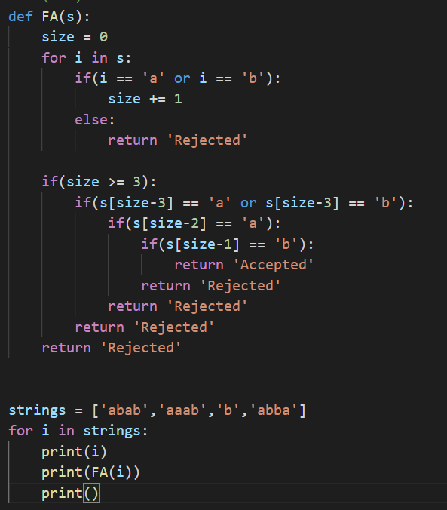

**Output:**

